NORTH BEACH ELEMENTARY SCHOOL

CRAZY GAMES CLUB-Spring 2018
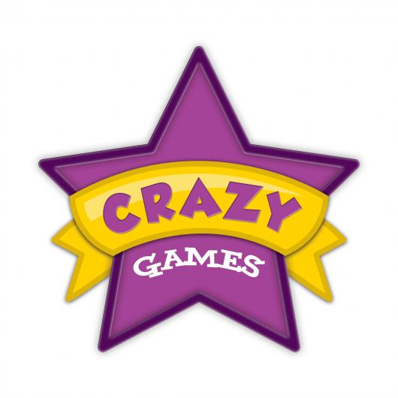

**You can now also register online at www.lifetimesports.org

Please either sign up online at www.lifetimesports.org or fill out the attached registration form and have your child bring it to the gym and give it to Mr. Hartmann either before or after school.

What: Crazy P.E. games…everything from Cosmic Bowling to Speed Stacking to Star Wars to Jail Break to Snowball Fights… with a few classics thrown in-between…a mix of the best P.E. games known to man/woman. Students will vote on their 8 favorite games which will determine the games we end up playing.

Who: 1st – 5th graders (SPACE IS LIMITED...on a first come, first serve basis)

Where: The North Beach Elementary School Gym

When: Spring Trimester: Mondays OR Thursdays from 2:25-3:25
Mondays= March 26th - May 21st{No club on Apr. 9th (Spring Break)
Thursdays= March 29th - May 24th {No club on Apr. 12th (Spring Break)

Cost: $140 (partial and full scholarships available to free and reduced lunch qualifying families.

Questions? Call or email Mr. Hartmann at (206) 252-1525 or rehartmann@seattleschools.org

What’s your favorite P.E. game? Well, chances are, we are going to get to play that game during Crazy Games Club. During the first day of club we will take a vote of our 8 favorite P.E. games and then we will play each of them during one of the weeks of club. By the end of the 8 weeks…we will have played all 8 of your favorite P.E. games!!

