Dear North Beach Families,
This year, the Science fair will take place on March 13th, 2014. Please register online at:
http://www.eyesforward.com/fair/
***Please note: DEADLINE to Register is March 7th, 2014***
If you do not have access to a computer or email, please send a note in to your teacher to contact me to help with registration.
This year students in the 3rd, 4th, and 5th grade are getting a packet that outlines what type of science fair project they may choose to do (K - 2nd grade may or may not receive a packet depending on teacher; participation in the science fair for K -2nd grade is voluntary).
All K-2 students who decide to enter will receive a ribbon for participating. The top projects for each grade will be awarded 1st, 2nd, 3rd place and honorable mentions for projects.
ALL participants will receive certificates with their name and project and Science Fair T-shirts if they are registered.
Please see below for a sample of the display, general rules and judging criteria:
-Student Name, grade and title of project MUST be clearly shown on display to be judged.
-NO animals may be brought to school.
-Due to students with severe Nut Allergies, please do not use Peanut Oil or Peanut butter in your project displays.
-Judging Criteria (in general): Visual Display, Creativity, Scientific & Clarity of Thought, Interview Questions & Oral Presentation
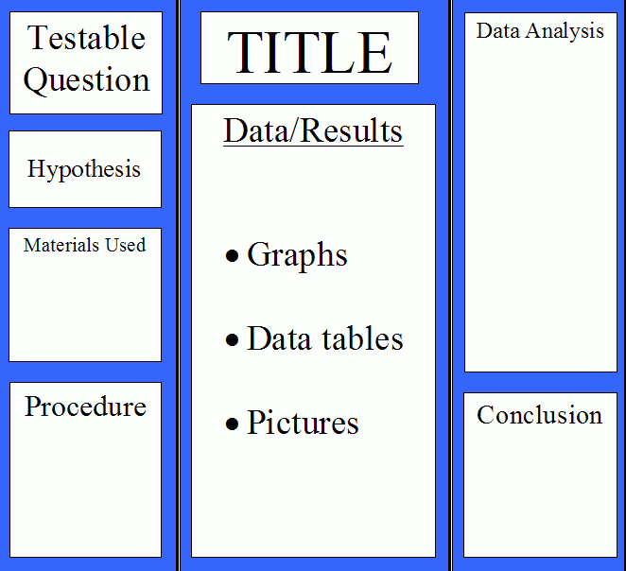

Thank you,
Anson Yuen
Science Fair coordinator
ayuen@dendreon.com
206-306-9107

