NORTH BEACH ELEMENTARY SCHOOL

UNICYCLING CLUB--Spring 2018

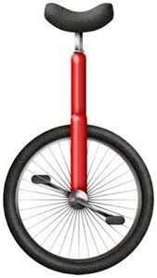

**You can now also register online at www.lifetimesports.org

What: Unicycling

Who: 3rd, 4th, and 5th graders

Where: The North Beach Elementary School Gym

When: Tuesdays from 2:25 - 3:25 Spring Trimester from March 27th – May 22nd
{no club April 10th (Spring Break)}

Cost: $140 (partial and full scholarships available to free and reduced lunch qualifying families)

Questions? Call Mr. Hartmann at (206) 252-1525 or email at rehartmann@seattleschools.org

Please fill out the attached Registration Form and have your child bring it to the gym and give it to Mr. Hartmann either before or after school.

Unicycle Club is a wonderful place to learn how to ride for the first time or to work on more advanced skills for those who already know how to ride. This is a great individual skill that teaches patience, self-motivation, perseverance and helps boost self-confidence. We will also be riding in the Ballard Parade in May. I look forward to seeing you there!

